

**Name: munira Mohamed Yousuf**

**Faculty: public health**

**Program: diploma**

**Class: online**

**Course: communicable disease**

**ID: DIP/25/406**

## Arthropod-Borne Infections

**Introduction**

Arthropods are a diverse group of invertebrates, including insects, ticks, mites, and others. Many arthropods are vectors, meaning they can transmit pathogens (viruses, bacteria, parasites) from one host to another. Arthropod-borne infections pose a significant global health burden, causing a wide range of diseases in humans and animals.

**Types of Arthropod Vectors and Associated Infections**

* **Mosquitoes:**
  + **Viruses:** Dengue, Zika, West Nile, Chikungunya, Yellow Fever, Japanese encephalitis, Eastern equine encephalitis
  + **Parasites:** Malaria, Filariasis (e.g., lymphatic filariasis)
* **Ticks:**
  + **Bacteria:** Lyme disease, Rocky Mountain spotted fever, Ehrlichiosis
  + **Viruses:** Tick-borne encephalitis, Crimean-Congo hemorrhagic fever
* **Fleas:**
  + **Bacteria:** Plague
* **Sandflies:**
  + **Parasites:** Leishmaniasis
* **Mites:**
  + **Bacteria:** Scrub typhus

**Signs and Symptoms**

The signs and symptoms of arthropod-borne infections vary widely depending on the specific pathogen and the body system affected. They can range from mild, self-limiting illnesses to severe, life-threatening conditions. Common symptoms include:

* Fever
* Headache
* Body aches and joint pain
* Rash
* Fatigue
* Swollen lymph nodes
* Neurological symptoms (e.g., encephalitis, meningitis)
* Hemorrhagic fever (bleeding)

**Common Arthropod-Borne Infections**

* **Malaria:** Caused by Plasmodium parasites transmitted by Anopheles mosquitoes. Symptoms include fever, chills, and flu-like illness. Severe malaria can cause organ failure and death.

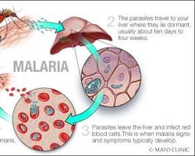

* **Dengue:** Caused by dengue viruses transmitted by Aedes mosquitoes. Symptoms include high fever, severe headache, joint and muscle pain, and rash. Severe dengue can cause bleeding and shock.

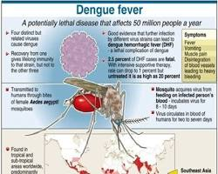

* **Zika:** Caused by Zika virus transmitted by Aedes mosquitoes. Symptoms are often mild, including fever, rash, joint pain, and conjunctivitis. However, Zika infection during pregnancy can cause severe birth defects.

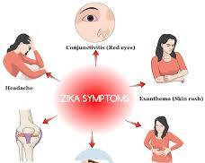

* **Lyme disease:** Caused by Borrelia burgdorferi bacteria transmitted by Ixodes ticks. Early symptoms include a bull's-eye rash, fever, and fatigue. Untreated Lyme disease can cause joint pain, neurological problems, and heart complications.

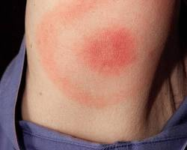

* **West Nile:** Caused by West Nile virus transmitted by Culex mosquitoes. Many people have no symptoms, but some develop fever, headache, and body aches. A small proportion develop severe neurological disease.

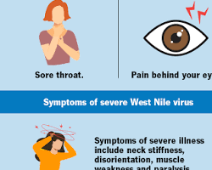

**Chikungunya:** Caused by Chikungunya virus transmitted by Aedes mosquitoes. Symptoms include fever and severe joint pain.

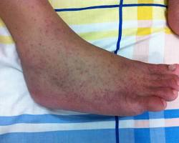

**Prevention and Control Measures**

* **Vector control:**
  + Eliminate breeding sites: Reduce standing water where mosquitoes breed.
  + Insecticides: Use insecticides to kill adult arthropods or their larvae.
  + Personal protection: Use insect repellent, wear long sleeves and pants, and use mosquito nets.
* **Vaccination:** Vaccines are available for some arthropod-borne diseases, such as yellow fever and Japanese encephalitis.
* **Public health measures:** Surveillance, disease monitoring, and health education campaigns can help prevent and control outbreaks.

**Diagnosis and Treatment**

* **Diagnosis:**
  + Clinical evaluation: Based on the patient's symptoms and medical history.
  + Laboratory tests: Blood tests, such as serology (antibody detection) and PCR (polymerase chain reaction), can identify specific pathogens.
* **Treatment:**
  + Supportive care: Many arthropod-borne infections have no specific treatment, and care focuses on relieving symptoms (e.g., fluids, pain medication).
  + Antimicrobial medications: Bacterial infections like Lyme disease and Rocky Mountain spotted fever are treated with antibiotics.
  + Antiviral medications: Some antiviral drugs are available for certain viral infections, but their effectiveness varies.
  + Antiparasitic medications: Parasitic infections like malaria are treated with specific antiparasitic drugs.